Updated and More Detailed Project Schedule Screenshots

**Table:**

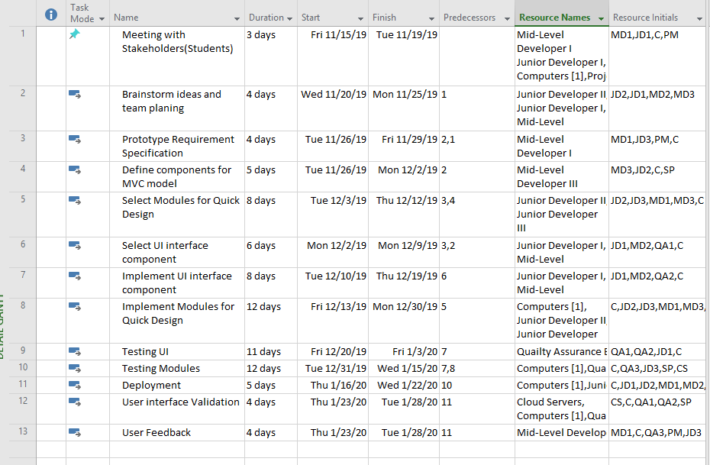

**Gantt Chart:** 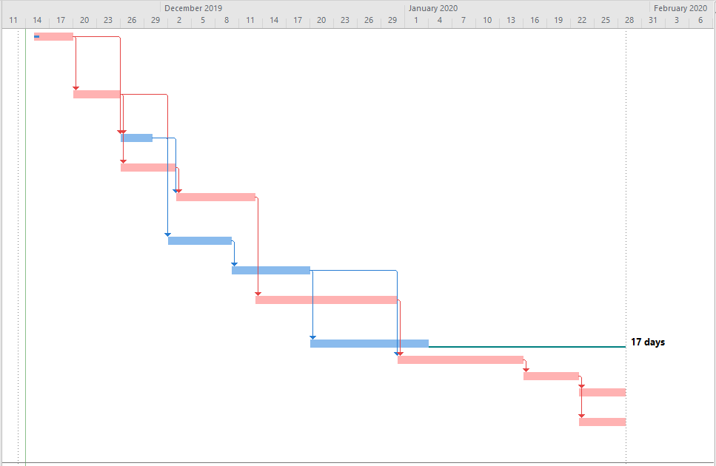

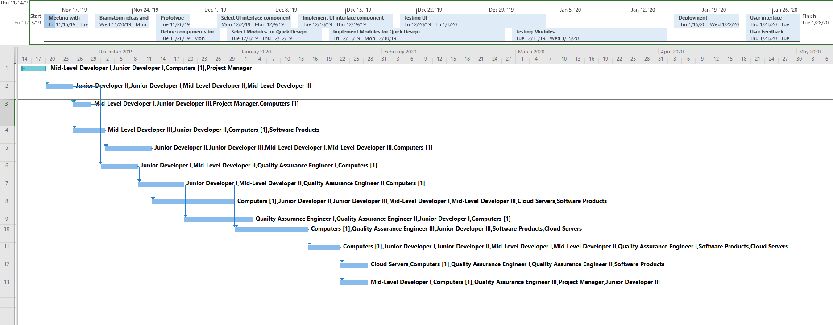**Timeline with Gantt Chart showing Resources:**

**Resource Sheet**

